**DAILY ONLINE ACTIVITIES SUMMARY**

|  |  |  |  |  |  |  |  |  |
| --- | --- | --- | --- | --- | --- | --- | --- | --- |
| **Date:** | **14-06-2020** | | | | | **Name:** | **pallavi** | |
| **Sem & Sec** | **6th sem ‘A’ sec** | | | | | **USN:** | **4AL17CS056** | |
| **Online Test Summary** | | | | | | | | |
| **Subject** | |  | | | | | | |
| **Max. Marks** | |  | | **Score** | | |  | |
| **Certification Course Summary** | | | | | | | | |
| **Course** | **Python for machine learning** | | | | | | | |
| **Certificate Provider** | | | **Great learning academy** | | **Duration** | | | **5hr** |
| **Coding Challenges** | | | | | | | | |
| **Problem Statement:**  1..write a java program to remove specific characters in the String If the original string is "Learning never stops" and the user inputs string to remove "estp" then the it should print "Larning nvr o" as output .  2.Write a C Program to implement the Binary | | | | | | | | |
| **Status:completed** | | | | | | | | |
| **Uploaded the report in Github** | | | | | **yes** | | | |
| **If yes Repository name** | | | | | <https://github.com/pallavi056/DAILY_STATUS> | | | |
| **Uploaded the report in slack** | | | | | **yes** | | | |

Online Test Details:

Certification Course Details:

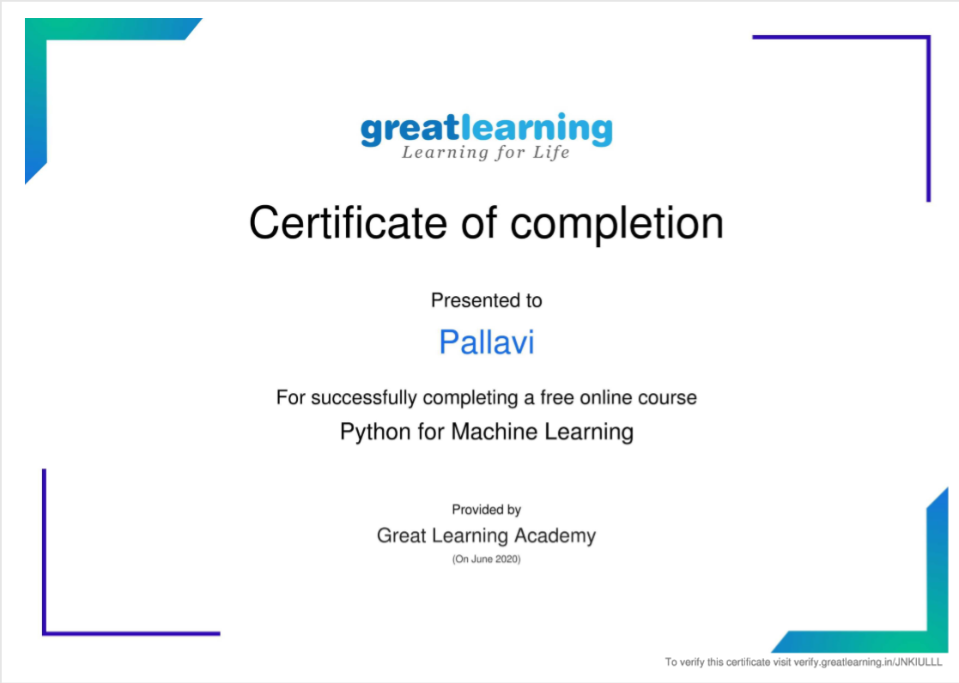

Coding Challenges Details:

[https://github.com/pallavi056/DAILY_STATUS/tree/master/14-06-2020/ONLINE%20CODING](https://github.com/pallavi056/DAILY_STATUS/tree/master/14-06-2020/ONLINE CODING)